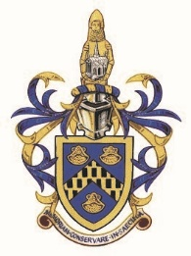
Monumental Brass Society ,
General meeting
on Saturday 27th October 2018
At All Hallows Church, Church Lane,
Tottenham, London, N17 7AA

12.00md Church and cemetery open to view
1.00pm Bruce Castle museum open

Programme of talks in All Hallows
2.00pm Opening remarks by Martin Stuchfield President of the MBS
2.10pm John Laverick, “A History of All Hallows Tottenham”.
2.30pm David Meara, “William Butterfield of this Parish”.
3.00pm tea and Tottenham cake (toilet facilities available in Bruce Castle).
3.50pm Philip Whittemore “Chasing shadows: the lost brasses of All Hallows”.
4.15pm Stephen Freeth, “Jeffreye Walkdine, skinner, Merchant Adventurer and member of the Muscovy Company.”
4.40pm Final remarks by Martin Stuchfield

ALL are welcome at this FREE meeting, no need to book

