THE CHURCH MONUMENTS SOCIETY
Patron HRH Duke of Gloucester KG GCVO
Registered Charity 279597
http://www.churchmonumentssociety.org

***The Church Monuments Essay Prize***

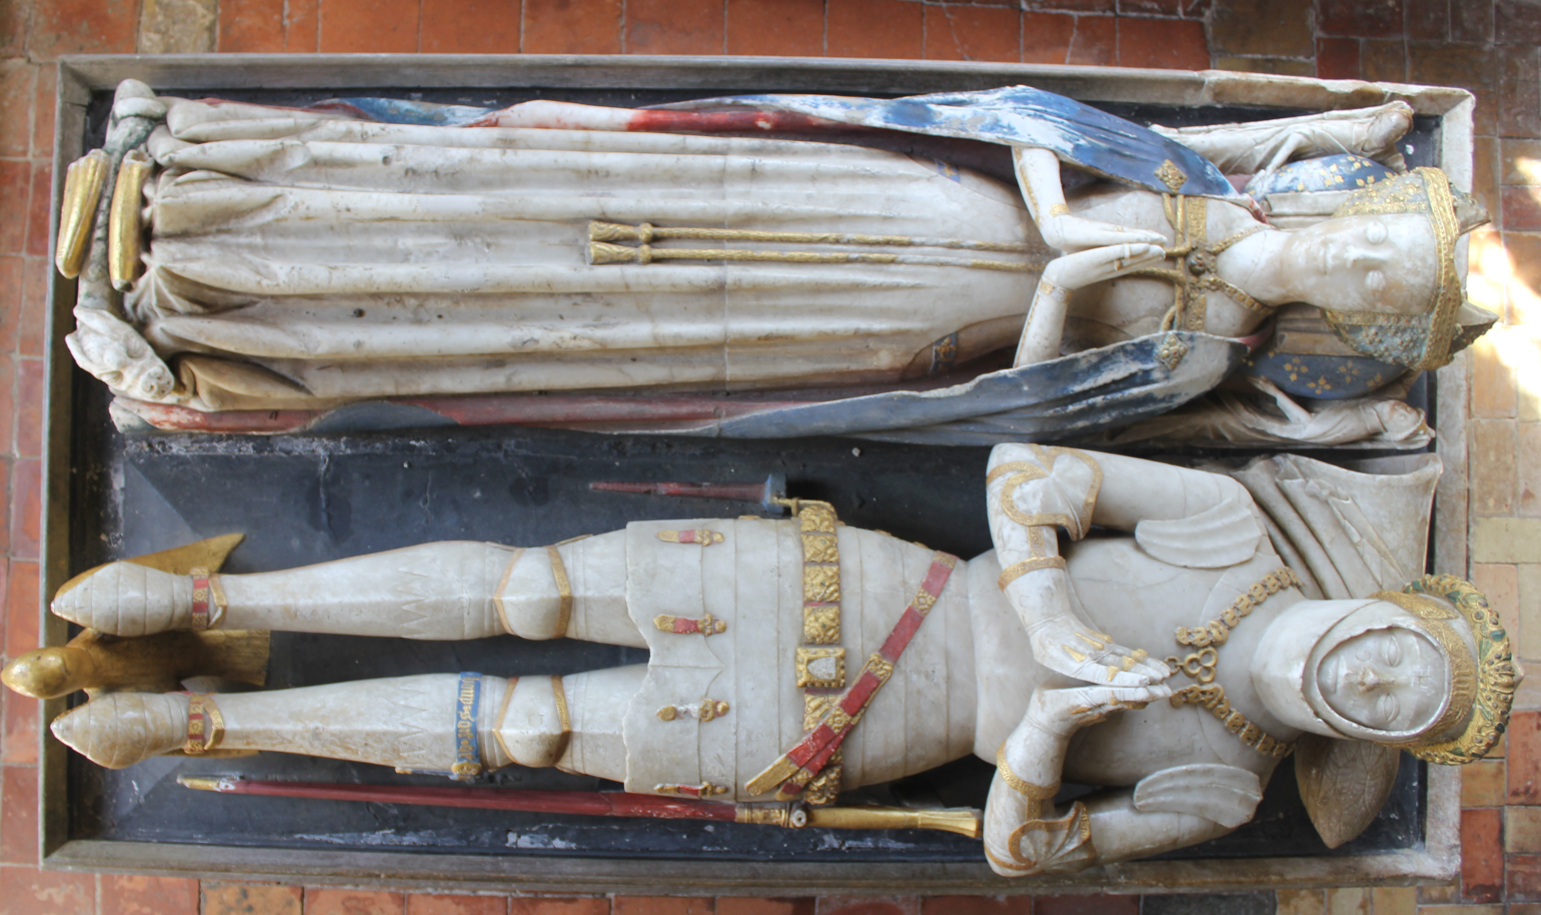
The Council of the Church Monuments Society offers a biennial prize of £500 called the Church Monuments Essay Prize, to be awarded with a certificate for the best essay submitted in the relevant year along with publication of the winning essay in the peer-reviewed international annual CMS journal Church Monuments.

The competition is open only to those who have not previously published an article in Church Monuments. The subject of the essay must be an aspect of church monuments of any period in Britain or abroad. The length (including notes) shall not exceed 10,000 words and a maximum of 10 illustrations, preferably in colour. The prize will only be awarded if the essay is considered by the judges to be of sufficiently high standard to merit publication in Church Monuments.

The closing date for new entries is 31 December 2020. For a copy of the rules and for the guidelines to contributors please see the Society’s website www.churchmonumentssociety.org, or contact the Hon. Journal Editors for more details and/or advice on the suitability of a particular topic.

For details and for submission of articles (deadline 31 December 2020) please email the Editors:

Jonathan Trigg Ann Adams
jrtrigg@liverpool.ac.uk cmsed.aja@gmail.com

Alabaster effigies of William Phelippe, Lord Bardolph, and Joan Bardolph, c.1450, Dennington (Suffolk).
Photo: Mark Downing

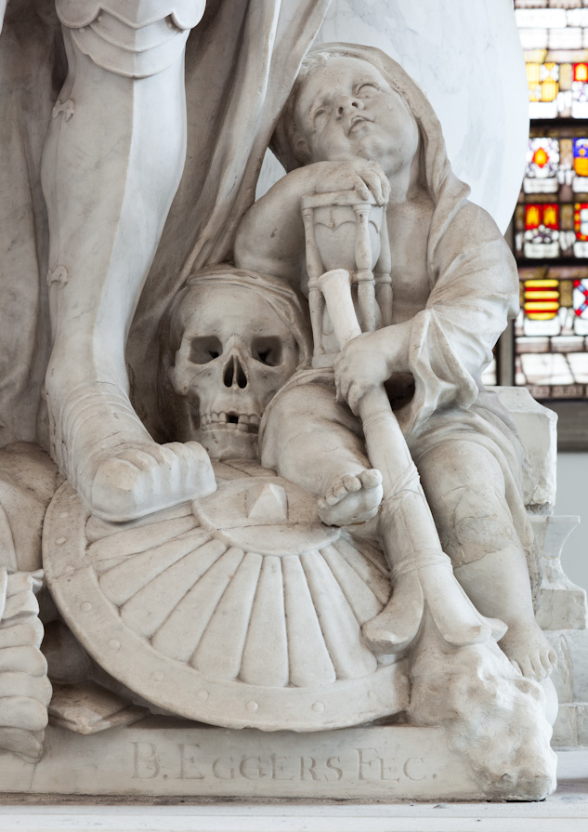
Mourning cherub with skull, torch and hourglass, by Bartholomeus Eggers, detail of the marble cenotaph of Lieutenant-Admiral Jacob van Wassenaer Obdam (killed in the Battle of Lowestoft, 13 June 1665),
Jacobskerk, The Hague (Netherlands). Photo: Chris Booms

